YOUR NAME
MASTER APPLICATION WORKSHEET
(Autobiography / My Life Story)

Personal Information Contact Block for Resumes, with example 2
Work Experience 3
Education and Training 5
Volunteering 7
Professional Organizations 8
Technology & Special Skills 9
Recognition (Honors & Awards) 10
Other Information 11
Salary History 12
Residence History 13

Note: In each section, begin with the present/most recent event and organize chronologically back in time to about age 14. You will need to copy the block shown in each section as a format for each event.

Consider creating a timeline BEFORE you work on your history. Write today’s date at one end of the timeline and the year you were 14 at the other. Between the two, when did you finish high school and/or move out on your own? Construct a list of major events in your work life and in your education and training. Now you have a way to organize details of your experiences, sorting out your actions and accomplishments.

Some people find it useful to jot down a list of where they lived and when they moved over the years. Thank might help to jog your memory, too.

Others find it useful to request an earnings history from the Social Security Administration (https://www.ssa.gov/forms/ssa-7050.pdf). There is a fee and the response may not be quick, but the information may be useful. Also, if you can access records used in establishing a security clearance, you will save time in developing your history.

Once you get the dates and places listed, focus on what you accomplished in each situation. Use action verbs that describe what actions you took!

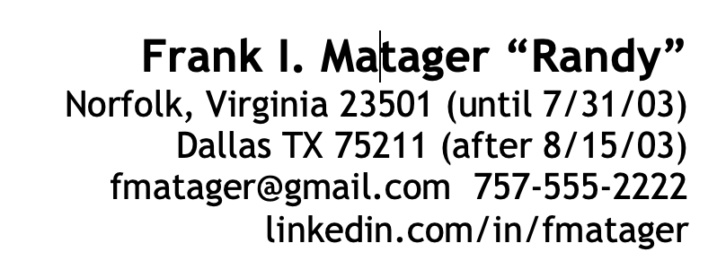
Personal Information
Contact Block for Resumes, with example
Full name and nickname, if any:
City, state, zip:
Cell:
Email:
Linkedin address:

Full Name (on legal documents):
Name you go by/nickname:

Social Security Number: XXX-XX-XXXX (enter last four only)

Citizenship: US (passport # and date for renewal)
Date of Birth: DD MMM YYYY
Health:
Security Clearance:

E-mail Address for career:
E-mail Address for personal use

Telephone (cell) XXX-XX-XXXX

LinkedIn Address:
Teams Address:
Zoom Address:

Career Goals:

Short-term occupational goal (6 months – 1 year):

Long-term career goal (5 – 10 years):

Immediate targeted occupation (job)

Immediate targeted industry/field/profession:

Long-term targeted occupation (job)

Long-term targeted industry/field/profession:

Legacy goal (what do you want to accomplish in your lifetime:

Work Experience
Start with your most recent job and work back. Unpaid positions can be considered work experience.

NOTE: Copy to make a separate entry for each assignment and each location

Job Title: Trainer

Company Name and Location: XYZ Company
Supervisor’s name and contact information:

Dates: from DD MMM YYYY to DD MMM YYYY

Salary: starting $XXXXXX ending $XXXXXX

Description of accomplishments/items found on reviews:

Accomplishments/honors/awards:

What did you dislike about this job? Did not care for being on call nights and weekends; did not like the amount of turnover on our team

What did you like about this job?

Job Title:

Company Name and Location:

Supervisor’s name and contact information:

Dates: from DD MMM YYYY to DD MMM YYYY

Salary: starting $XXXXXX ending $XXXXXX

Description of accomplishments/items found on reviews:

Accomplishments/honors/awards:

What did you dislike about this job? Did not care for being on call nights and weekends; did not like the amount of turnover on our team

What did you like about this job?
Job Title:

Company Name and Location:

Supervisor’s name and contact information:

Dates: from DD MMM YYYY to DD MMM YYYY

Salary: starting $XXXXXX ending $XXXXXX

Description of accomplishments/items found on reviews:

Accomplishments/honors/awards:

What did you dislike about this job? Did not care for being on call nights and weekends; did not like the amount of turnover on our team

What did you like about this job?

Education and Training

High School:

Name and Address:

Year Graduated:

In what subjects did you do best?

What subjects did you like most?

What subjects did you like least?

Honors/awards/accomplishments:

Clubs/ organizations (offices held/ duties, accomplishments):

Colleges Attended
NOTE: Copy to make a separate entry for each assignment and each location

Name and Location:

Year Graduated: credits earned, if any

In what subjects did you do best?

What subjects did you like most?

What subjects did you like least?

Honors/awards/accomplishments:

Clubs/ organizations (offices held/ duties, accomplishments):

Graduate Education
NOTE: Copy to make a separate entry for each assignment and each location

Name and Address:

Year Graduated:

In what subjects did you do best?

What subjects did you like most?

What subjects did you like least?

Honors/awards/accomplishments:

Clubs/ organizations (offices held/ duties, accomplishments):

Training
(professional, technical, clerical, management, license, certificate, etc., training programs)
NOTE: Make a separate entry for each training program completed

Name and address of education or technical institute of location of training:

Course(s) attended:

Date attended:

Hours/credits completed:

Certificate/license earned:

Honors/awards:

Volunteering
NOTE: Copy to make a separate entry for each experience

Organization/Cause:
Location:
Start and End Years:
Projects or Role:

Professional Organizations
NOTE: Copy to make a separate entry for each

Name:
Start and End Dates
Specific roles/offices if held
Special projects

Technology & Special Skills
NOTE: Copy to make a separate entry for each assignment and each location. If you have taken a certification exam, list it with the company name and the date you earned the certificate.

Foreign languages/American sign language
Fluent in:
Knowledge of:

Computer Languages
Fluent in:
Knowledgeable of:

Computer Hardware
Expert in:
Knowledge of:

Computer Software
Expert of:
Knowledge of:

Machines/Equipment
Operate:
Repair:

Clerical Skills
Other:

Technical Skills
Name and Acronym:

Recognition (Honors & Awards)
NOTE: Copy to make a separate entry for each

Name Emporium School Spelling Bee First Place
Conferred by Emporium Schools Board of Directors
Date
For (reason conferred) For correctly spelling something, placing first among 50 students

Name
Conferred by
Date
For (reason conferred)

Name
Conferred by
Date
For (reason conferred)

Other Information

Hobbies/Interests:

Publications/Presentations:

Grant Projects Funded:

Other Items:

Salary History

Company, Title, Place, Dates, Hourly and Annual Wage at End

Residence History

From infancy to present – full address and dates of all placed lived

